**DEEP LEARNING**

**Lab Assignment -2**

**UMKC**

**Name-Mohammad Mohsin Ali**

**Id-16246618**

**Class Id -26**

**Introduction:** This assignment deals with implementation of CNN using tensor flow concepts.

**Task:** Load the data having 5 classes, run CNN model and see the graph on tensor flow(also change the hyper parameter and compare the result).

**Approaches:**

First, we train the model and the predicating the data. changing the hyper parameter and compare the result

**Workflow:**

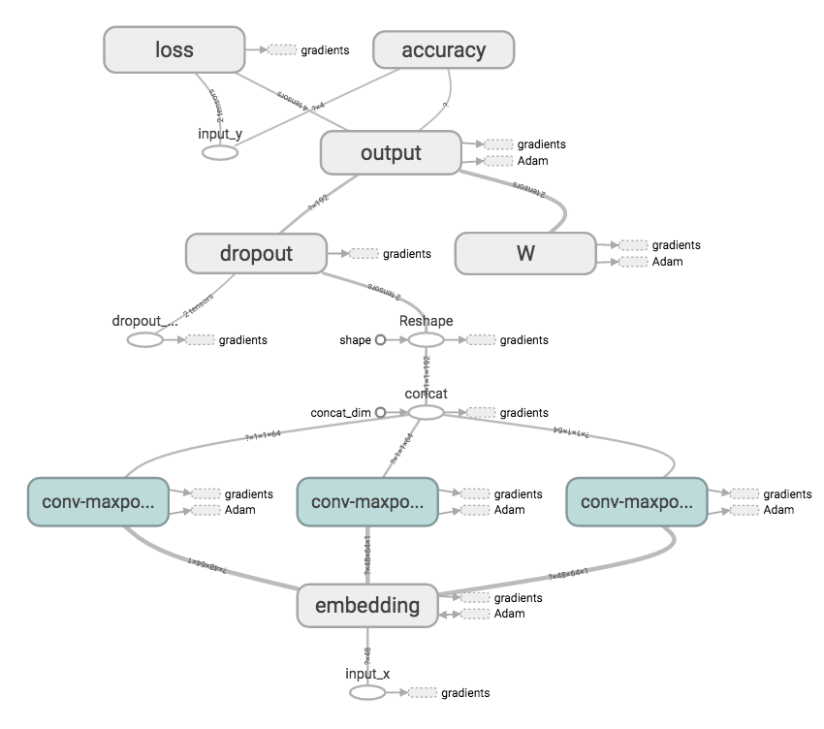

**Datasets:**

The data set I used is given by the CFPB. The data is the complaints about the financial products and services to the companies for response. Our data set contain 11 classes.

**Parameters:**

* num_epochs: 1,
* batch_size: 37,
* num_filters: 32,
* filter_sizes: "3,4,5",
* embedding_dim: 50,
* l2_reg_lambda: 0.0,
* evaluate_every: 200,
* dropout_keep_prob: 0.5

**Evaluation:**

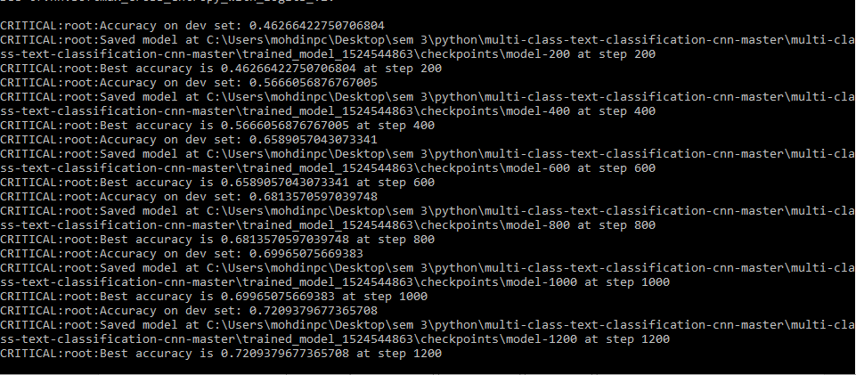

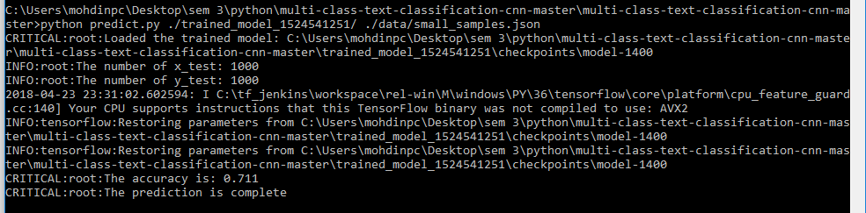

This final evaluation of this project.

**Conclusion:**

200 step the model accuracy was 46, 400 it becomes 65%. finally 1200 we get best accuracy of the model is 72%. Accuracy is increased with increased steps.